Thursday, 3 November 2022
PRESS RELEASE

'THE SUPRISING FRESHNESS OF CONTEMPORARY ART' TO SETTLE IN THE PLEČNIK HOUSE

I am only the housekeeper, but I don't know…
temporary exhibition
Plečnik House, 8 November 2022–8 January 2023

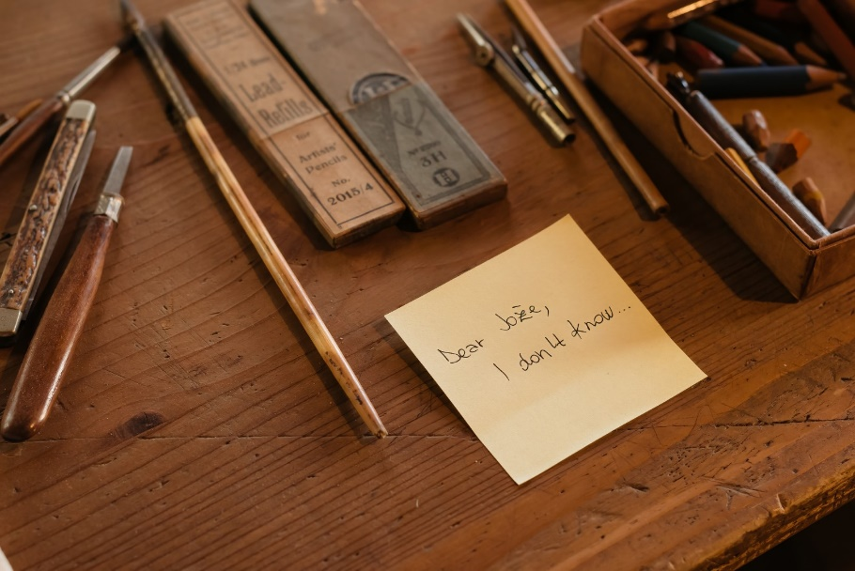
The last exhibition of Plečnik's jubilee year 2022 is opening at the Plečnik House on Tuesday, 8 November. The exhibition will present a contemporary hommage of Plečnik's oeuvre. The curation of the show, titled I am only the housekeeper, but I don't know…, was entrusted to two visiting curators: Luca Lo Pinto, Artistic Director of Rome's MACRO Museum, and German artist Olaf Nicolai.
The curatorial duo invited 25 internationally recognised Slovenian and foreign artists and creators, who are entering the architect's house through their diverse and various works.

Tuesday, 8 November, at 6.00 pm
Opening of the exhibition I am only the housekeeper, but I don't know… at the Plečnik House, in the company of Blaž Peršin, director of the Museum and Galleries of Ljubljana, and the exhibition’s curators, Olaf Nicolai and Luca Lo Pinto. The exhibition opening will be highlighted with a performance of actress Saša Pavček.

Contemporary interventions into the context of the Plečnik House were done by the curators Luca Lo Pinto and Olaf Nicolai in close collaboration with the curator of the Plečnik House, Ana Porok. Works of invited authors commemorate Plečnik's oeuvre and place the reading of his works into a different and very modern context. Blaž Peršin, the director of the Museum and Galleries of Ljubljana, thus highlighted:

“Paying us a visit at the Plečnik House are the Italian curator Luca Lo Pinto and the German artist Olaf Nicolai. Together with the artists they invited, they made small contemporary interventions in the house, which speak of Plečnik's work and his world of thought with surprising freshness. The purpose of their meticulous interventions is to open the dimensions and locations of Plečnik's home in a completely different way from what we are accustomed to. They have woven a web of stories, objects, and mental connections, which we fail to notice immediately as we need the virtue of patience and the ear of the storyteller. Thus, we want to actualise Plečnik’s heritage and connect it with the time and space of today.”

The curated intervention of Luca Lo Pinto and Olaf Nicolai presents artworks, gestures, whispers, sounds, and actions which included the collaboration of 25 Slovenian and foreign authors, among them also chef Ana Roš, landscape architect Ana Kučan, and actress Saša Pavček:
John Armleder, H. C. Artmann, Nairy Baghramian, Pierre Bismuth, Monica Bonvicini, Pablo Bronstein, Michael Dean, Jason Dodge, Hansi Fuchs, Lena Grossmann, Ana Kučan, Janette Laverrière, Enzo Mari, Hana Miletić, Carsten Nicolai, Saša Pavček, Julie Peeters, Manfred Pernice, Florian Pumhösl, Fabio Quaranta, Ana Roš, Giovanna Silva, Mladen Stilinović, Diamond Stingily, and Sophie Thun.

The curators based the exhibition concept on a (fictitious) letter that the housekeeper Urška wrote to Plečnik:

Dear Jože,

Today I met with two men who visited your house. They spent a lot of time here and loved your place. They asked if it would be possible to add some small objects in your house, which would join your things for a little while and keep them company. They said something like, “Things could talk to things”, which I thought was odd, but also quite touching.
I told them right away that you probably would not have liked that. I just could not imagine you approving of it.
But then they would not stop talking about you and the house. During the conversation, when I had made them some tea, they suddenly asked me to share things I would have suggested you.
Just small, possible changes and thoughts I may have had, and they would try to come up with ways in which these ideas, wishes, and gestures could be presented to you.
At first I just thought, “Oh, no!”
I remembered what happened that one time with the toilet! I couldn't stop the city council from installing a flush toilet in your absence. They assumed it would have pleased you.
I will never forget your drastic comment, “I want to hear how shit falls.” Yes, you said, “shit!” and then everything had to be removed.
No, after that ordeal I swore to myself that I would never let it happen again! I never want to hear those words ever again.
Yet, after this conversation, I began to think. Why should we not make some changes? It could prove to be a good idea, and I really started to give it some thought.
You know, I have always kept a low profile and tried to unobtrusively look after the house, adhere to your wishes, and make sure that everything was in its place, so that you could go about your work in peace.
Nonetheless, I admit that several ideas have crossed my mind. At times I thought about the possibility of changing this or that in the house and around the garden. I am not talking about big changes or renovations... Just small things, signs, gestures. Perhaps, even just suggestions.
They came back the following day, and we decided to keep the conversation going and share our thoughts. So, I have to admit that we did start to collaborate.
You will find your house has changed a little bit now. You will also hear some stories. Please, do not be afraid or grumpy. Maybe you will see it as I do: a starting point. For what we do not yet know, nor do we know where it will lead us to…
Those who will see it will hopefully understand that things can be a certain way, and that they can also be different.
Imagine if the bells in the church tower next door did not only ring every hour on the dot, but also nine minutes past noon.
Urška

Photo at the top:
photo by: Blaž Gutman / MGML

Exhibition credits
I am only the housekeeper, but I don't know...
temporary exhibition
8. 11. 2022–8. 1. 2023

Museum and Galleries of Ljubljana, Plečnik House
Represented by: Blaž Peršin, Director

Authors: John Armleder, H. C. Artmann, Nairy Baghramian, Pierre Bismuth, Monica Bonvicini, Pablo Bronstein, Michael Dean, Jason Dodge, Hansi Fuchs, Lena Grossmann, Ana Kučan, Janette Laverrière, Enzo Mari, Hana Miletić, Carsten Nicolai, Saša Pavček, Julie Peeters, Manfred Pernice, Florian Pumhösl, Fabio Quaranta, Ana Roš, Giovanna Silva, Mladen Stilinović, Diamond Stingily, Sophie Thun

Artworks: artists’ collections; private collections; Jan Mot, Brussels; Galleria Raffaella Cortese, Milan; Galerie EIGEN+ART Leipzig / Berlin; Queer Thoughts (New York), Cabinet Gallery (London); Sammlung Maaß/ Lukas, München

Curators of the exhibition: Olaf Nicolai, Luca Lo Pinto
Production of the exhibition: Maja Kovač, Ana Modic

Graphic design: Julie Peeters, Jaka Šuln
Language editing: Katja Paladin
English translation: Matic Šavli
Promotion: Maja Kovač, Nejc Kovačič

Exhibition layout: Conservation department of MGML, Technical department of MGML

