36th Ljubljana Biennale of Graphic Arts. The Oracle: On Fantasy and Freedom

The Ljubljana Biennale of Graphic Arts will celebrate its 70th anniversary in 2025

Preview 5 June
Dates: 6 June to 12 October 2025
Curated by Chus Martínez

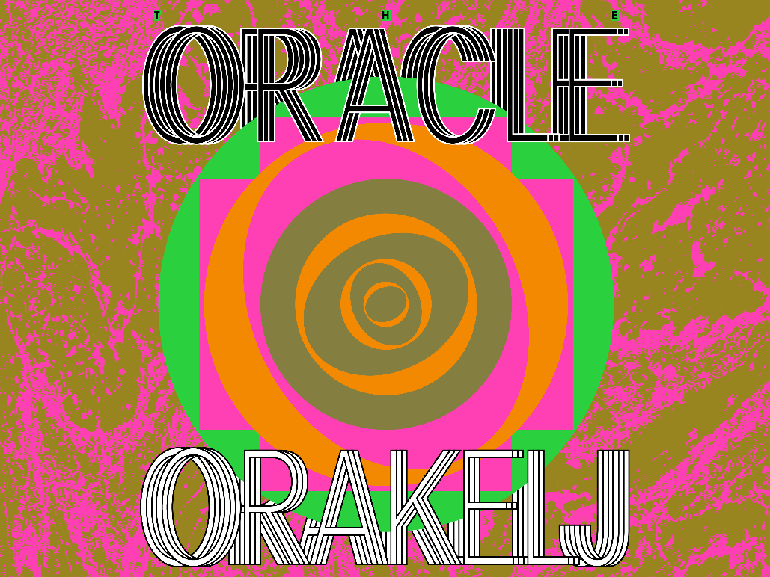

MGLC, the International Centre of Graphic Arts, today unveils the full concept, plans, and artist list for the 36th Ljubljana Biennale of Graphic Arts—The Oracle: On Fantasy and Freedom—which takes place from June 6 to October 12, 2025. The 36th edition will be curated by renowned curator, lecturer, and researcher Chus Martínez as Artistic Director.

The Ljubljana Biennale of Graphic Arts is celebrating its 70th anniversary in 2025. Since its beginning in 1955, the Biennale has showcased the works of around 9,000 artists from 122 countries. Throughout its history, it positioned Ljubljana and Slovenian art into a global context and helped shape the international discourse in the fields of printmaking and contemporary art. In 2001, marking a significant shift from national selections to a curated exhibition format, the Biennale began commissioning new works, resulting in 245 new art pieces to date. This period also saw the involvement of 30 curators and the utilisation of 53 exhibition venues, reflecting the Biennale’s ongoing evolution as a space for experimentation, critical reflection, and inter-institutional collaboration.

The 36th edition of the Biennale unfolds in various venues across the city. This will include the International Centre of Graphic Arts (MGLC), producer of the Ljubljana Biennale of Graphic Arts, which is located in two outstanding historic buildings in the heart of Ljubljana’s Tivoli Park (Grad Tivoli and Švicarija); outdoor venues in Tivoli Park with two site specific projects; the Museum of Modern Art (Moderna galerija) situated at the south end of the park; and the City Art Gallery Ljubljana (Mestna galerija Ljubljana) in the city centre. All works—apart from two—have been specifically produced for the Biennale and are new commissions to be seen for the first time this summer.

Artists taking part (bold = in City Art Gallery Ljubljana):

Sinzo Aanza, Noor Abed, Gabriel Abrantes, Saelia Aparicio, Maria Arnal, Canan, Gabi Dao, Manca G. Renko, Grupa Ee, Miles Howard-Wilks, Joan Jonas, Jane Jin Kaisen, Ema Kugler, Nicole L’Huillier, Svetlana Makarovič, Yarema Malashchuk in Roman Khimei, Manuela Morales Délano, Eduardo Navarro, Ingo Niermann in Mayte Gómez Molina, Silvan Omerzu, Ajša Pengov, Nohemí Pérez, Juan Pérez Agirregoikoa, Vesna in Eugen Petrešin, Maja Petrović-Šteger, Sadie Plant, Tarta Relena, Renata Salecl, Kathrin Siegrist, Svetlana Slapšak, Mladen Stropnik, Olga Subirós, Derek Tumala, Aili Vint, Takeshi Yasura

The concept of the Biennale:
The Oracle names and honours the symbolic place from where all beings wonder about the course of life. Because we care about tomorrow, we should assume we care about staying alive, about a world in peaceful coexistence. Times of increasing insecurity and the experience of living in a world that refuses to accept our needs give birth to many forms of escapism and misleading decision-making. Searching for big answers and the expectation of big movements capable of undoing the damage of wars and dark forces seems unrealistic. Art—all arts—assumes the existence of a tiny but meaningful spot from where to be free and dream and demand freedom and peace. This exhibition is about this tiny spot. This Biennale claims that every art and cultural manifestation is an oracle, a place we are given to reflect and ponder on how common good is possible, how a good life based on shared values is to be achieved.

This Biennale is, then, an oracular place, a place for interpretation, and at the centre of The Oracle in Ljubljana is Žogica Marogica, Speckles the Ball. Žogica is a figure that embodies tradition, politics, and the need to invent systems able to transmit, educate, and connect people. Almost every citizen in Slovenia knows this puppet. A colourful head-ball created by artist Ajša Pengov for a play, written by Jan Malík (1904–1980), that was staged at today’s Ljubljana Puppet Theatre in 1951 and that immediately became an incredible hit after its Ljubljana puppet and radio premiere, and that has now lived on the puppet stage for several decades. The puppetry traditions and their interest in inventing autonomous beings made by craft and fantasy have an enormous potential to reflect on many of the issues that affect the modelling of our world scenarios today: gaming technology; disembodied and autonomous intelligences capable of surpassing the human; analogue mass education in times of the digital; new forms of folklore to bond and dream together. Žogica, a puppet born out of the concern about who controls whom, connects the old dream of autonomy with the new nightmares around technology. When creating puppets, writer Ajša Pengov wondered: Should puppets be operated by hands or strings? Should they be an extension of our human body or become independent? Not modelled on the theatre of human actors, but autonomous in their movements and expressions. Ultimately, the eternal question of control and controlling instead of enabling, fostering, and enhancing peaceful and fertile ways of living is what concerns this Oracle.

Peace is only possible if we love the world we live in, which is a very difficult task today. This exhibition is about learning to do so.

Chus Martínez explains, Times of increasing insecurity and the experience of living in a world that refuses to accept our needs give birth to many forms of escapism and misleading decision-making. Searching for big answers and the expectation of big movements capable of undoing the damage of wars and dark forces seems unrealistic. A biennale constitutes an environmental practice; that is, it forces us to look into a particular place and cultural context again and again. There, I found Žogica, a figure that embodies tradition, politics, and the need to invent systems able to transmit, educate, and connect people.

The Biennale curator, Chus Martínez, has also been producing a weekly column for Mousse magazine about the process of curating the Biennale. As well as an exhibition guide, a publication with texts by Manca G. Renko (historian), Sadie Plant (philosopher), Renata Salecl (philosopher and sociologist), Svetlana Slapšak (anthropologist, classical philologist, writer, and historian), and Maja Petrović-Šteger (social anthropologist) will be published by Sternberg Press. The exhibition’s graphic design is by Grupa Ee.

International media office:
Studio Nicola Jeffs
Nicola Jeffs
nj@nicolajeffs.com
Siobhan Scott
ss@nicolajeffs.com
+44 7794 694 754

Note to editors
The Ljubljana Biennale of Graphic Arts is one of the oldest biennials in the world. It was founded in 1955 and will celebrate its 70th anniversary with its upcoming edition this year. With its activities, it positioned Ljubljana and Slovenian art into a global context, influenced the development of many similar events around the world, and created an active network of knowledge exchange in the field of graphic arts.
Today, the Biennale is a vibrant, constantly shifting platform for artistic creation and critical analysis of societal events. It is characterised by the democratisation of art and culture and, at the same time, by elusive, overlapping forms of knowledge, experience, and practice.
The 36th edition of the Biennale, under the artistic direction of Chus Martínez, will be created in cooperation with a number of international partners (to be announced) and national partners including the Museum of Modern Art (Moderna galerija), under whose auspices the Biennale was held until the establishment of the International Centre of Graphic Arts in 1986.

