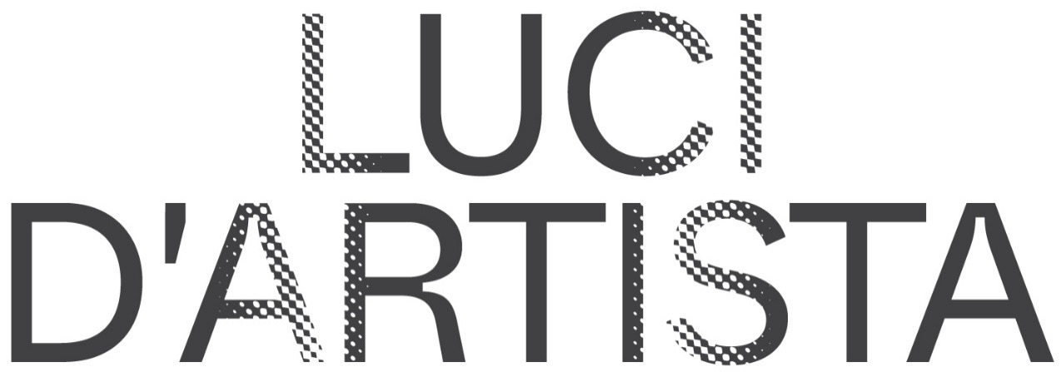

CANEMORTO
THE RADIANT VAN

Turin / Ljubljana / Venice / Turin – March-October 2026

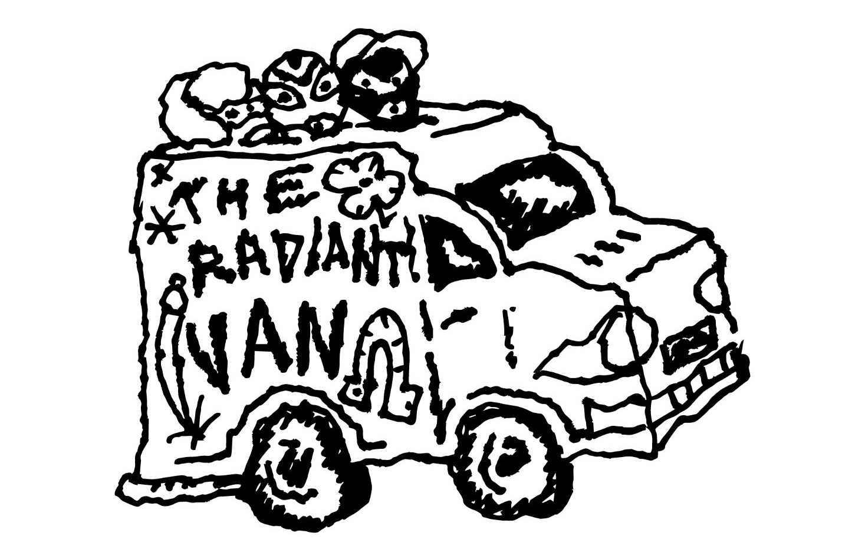

On March 11, The Radiant Van – the new Luce d'Artista conceived by the iconic anonymous trio CANEMORTO – will set off from Turin on a five-day journey-performance: a van transformed into a mobile light installation that will accompany the artists to Ljubljana, launching a multi-phase project encompassing the production of the artwork, the creation of a short film, an exhibition, events in Venice during the 61st International Art Exhibition of the Biennale, participation in a festival in Ljubljana, and finally, the return home to Turin to find placement in the public space.

The project stems from the curatorial vision of Antonio Grulli, who has directed Luci d'Artista since its 26th edition, and his choice to invite CANEMORTO to create a new light artwork.
The project is made possible thanks to the support of the General Directorate for Contemporary Creativity of the Ministry of Culture, within the framework of the Italian Council program (14th edition, 2025), aimed at the international promotion of Italian contemporary art.
The new Luce d’Artista will enter the collection of the City of Turin starting from the 29th edition (2026–2027), part of the city’s public heritage managed by Fondazione Torino Musei since 2022.
The Van is not merely a means of transport, but a genuine light installation in motion. On board travel the artworks destined for The Painting Race exhibition at Ljubljana's Match Gallery, and the journey itself activates a narrative in movement. Traveling alongside CANEMORTO are director Marco Proserpio, sound technician Matteo Pansana, and photographer Alessandro Trapezio for a series of video and photographic shoots documenting a physical and symbolic connection between Turin and Ljubljana. The journey thus becomes an integral part of the artwork and will result in an original short film and photographic material for the catalogue.
The project develops from two archetypes connected to Turin: its automotive industrial vocation and its relationship with the magical and esoteric dimension. CANEMORTO transforms a classic work van into a "magic lantern in motion": perforated panels, engravings, and an internal lighting system – also powered by solar energy – project a constellation of apotropaic signs into space.

The vehicle's sides are engraved with 18 universal symbols inspired by white magic tradition and reinterpreted in the trio's stylistic language. Light filters through the surfaces, transforming the vehicle into a mobile talisman capable of activating a different relationship each time with the places it crosses and temporarily inhabits.

The various phases of the project, from the artwork's production to the journey's stages and public presentations, will be documented through continuous updates on www.lucidartistatorino.org and on Luci d'Artista's social media channels, allowing followers to track The Radiant Van's evolution.

THE PROGRAM

The project's first stage is CANEMORTO's solo exhibition The Painting Race at Ljubljana's Match Gallery (March 31 – May 10, 2026) curated by Jani Pirnat and Antonio Grulli: remote-controlled paintings equipped with wheels traverse a circuit running through all the gallery rooms, transforming painting into a dynamic, nomadic, and performative experience. Each painting is linked to a particular moment in art history that defines its team affiliation: we have landscape, post-expressionism, magic realism, and neo-abstraction, all competing to prevail over other genres or pictorial schools. The allusion to and parody of the competition inherent in the art system is evident. The remote-controlled paintings can be freely used by the public to play and compete. Simultaneously, some "official" races will be organized among figures – artists, curators, collectors – connected to Ljubljana's art scene. Meanwhile, a series of drawings related to the world of automobile racing will be displayed on the walls.

The Radiant Van will then travel to Venice for the opening week of the 61st International Art Exhibition of La Biennale, in collaboration with the Fondazione Musei Civici di Venezia (MUVE). From 6 to 10 May, concurrently with the exhibition Granda. Gli artisti degli Atelier 2024–2025, it will be displayed in front of the Casermetta Est at Forte Marghera.
During those days, the CANEMORTO triad will activate the Van through a series of performances taking place in selected locations across the lagoon city.

From May 26 to June 22, The Radiant Van will be presented to the public as part of the 20th edition of the Lighting Guerrilla Festival, one of Europe's leading events dedicated to light art, curated by Katerina Mirović and Nika Erjavec. The 2026 edition's theme is Diversities, which invites exploration of how art, through the medium of light, makes visible presences and absences, what emerges and what remains on the margins. In this context, CANEMORTO's work will be placed in Ljubljana's urban space, in front of Match Gallery, temporarily transforming the location into a performative landscape and renewing its relationship with the city context.

On June 10, within the festival framework, the project catalogue will be presented, with contributions by Antonio Grulli (Luci d'Artista curator), Jani Pirnat (Match Gallery curator), and Matjaž Brulc (Strip Core / Lighting Guerrilla Festival). On this occasion, Marco Proserpio's short film dedicated to The Radiant Van's journey-performance will also be screened.
After the Slovenian stage, the Van will return to Turin, where it will enter the permanent Luci d'Artista collection starting from the 29th edition (2026–2027), continuing to exist as a light artwork and as an active device in public space.

The project is realized by Fondazione Torino Musei for Luci d’Artista in collaboration with Match Gallery / Museum and Galleries of Ljubljana (MGML), Forum Ljubljana – Lighting Guerrilla Festival, and Fondazione Musei Civici di Venezia (MUVE).

Luci d'Artista is a project and heritage of the City of Turin, realized by Fondazione Torino Musei with support from Fondazione Compagnia di San Paolo and Fondazione CRT.

BIOGRAPHIES

CANEMORTO, an anonymous Italian artist trio founded in 2007, has built over the years a language that blends conceptual art, underground subcultures, and Dadaist provocation within a surreal macro-narrative where reality and fiction overlap. Painting, sculpture, video, and performance coexist in an expressionist, ironic, and destabilizing imaginary that finds in The Radiant Van a new form of expansion into urban space.

ANTONIO GRULLI (La Spezia, 1979) has been curator of the Luci d'Artista project since its 26th edition (2023/2024). He regularly collaborates with the newspaper La Stampa, for which he writes the column "Lampi Critici." He was curator of the Albanian Pavilion at the 60th Venice Biennale. Over the years he has handled the collection and contemporary art activities of Palazzo Bentivoglio (Bologna, palazzobentivoglio.org), was part of Viafarini's board (Milan, viafarini.org), and has created a series of exhibition, project, and editorial initiatives in collaboration with fellow curators, artists, and collectors. For MAMbo Museum in Bologna, he conceived (with curator Davide Ferri) Sentimiento Nuevo, research on the state of art criticism consisting of meetings, conferences, lectures, and performances. He curates two non-profit exhibition spaces: Lucerna, in Milan, together with Federico Pepe, and the FBI space in artist Jacopo Benassi's studio in La Spezia. Over the years he has curated exhibitions for public and institutional spaces including: Ala Scaligera at Rocca di Angera (Varese), Fondazione Carispezia (La Spezia), Fondazione del Monte (Bologna), Le Dictateur (Milan), Match Gallery (Ljubljana), MAMbo (Bologna), Museo di Castelvecchio (Verona); the non-profits C21 (Reggio Emilia), Codalunga (Vittorio Veneto), Hamlet (Zurich), Neon Campobase (Bologna), Viafarini (Milan). He has collaborated with publications including Arte e Critica, Arte Mondadori, Artnews Italia, Artribune, ATP Diary, Boite, Cura Magazine, Exibart, Flash Art, Le Dictateur, Mousse Magazine, and Studio Magazine.

JANI PIRNAT (1974), art historian and curator, a founding member of the Domestic Research Society which is curatorial and art group established in a year 2004 also by artists Alenka Pirman and Damijan Kracina. As a curator and organizer of art events, he was employed in by the SCCA - Centre for Contemporary Art Ljubljana (2003 – 2004), the National Museum of Slovenia (2007), Škuc Gallery Ljubljana (2010 – 2012), Celje Centre for Contemporary Art (2012 – 2013) and collaborated with Ljudmila Digital Art Laboratory. He was living and working in Osaka, Japan (2013-2015). Focusing on contentious cultural heritage research within Domestic Research Society he was part of consortium partnership for HORIZON 2020 project TRACES, researching death masks phenomena.
Currently he has a position of curator at the Museum and Galleries of Ljubljana (MGML), curating contemporary art program of Match Gallery. Between years 2016 and 2020 he was a coproducer and a member of art and organisation board of Indigo Festival Ljubljana.

KATERINA MIROVIĆ is a Slovenian curator and editor, and key figure in alternative culture, best known as a co-founder (1989) and artistic director of Strip Core, the visual arts and publishing section of Forum Ljubljana // Institute for Art and Cultural Production, where she is curator, producer and President of the Board. She co-founded influential comics magazine Stripburger comics magazine in 1992, and has been the editorial member since. With Aleksandra Stratimirović she co-founded international Lighting Guerrilla festival in Ljubljana, being its curator and producer ever since 2007. Since 1989 she has organized and/or curated several hundred visual art, media and music events in Slovenia and abroad. In 2018, she received a prize Priznanje Ivane Kobilice for her contribution in development of visual arts.

INSTITUTIONS

Luci d’Artista, founded in Turin in 1998 at the initiative of the City of Turin, Luci d'Artista is grounded in the belief that art should contribute to the common good and inhabit streets, squares, and buildings. This innovative public art project features a collection of over 30 light installations by leading Italian and international artists—including Merz, Pistoletto, Anselmo, Horn, Paolini, and Rehberger—transforming the city into an open-air museum each winter.
With its 26th edition (2023/24), the City of Turin entrusted management to Fondazione Torino Musei and appointed its first curator, Antonio Grulli, who approaches Luci d'Artista as a research institution with its own curatorial vision and year-round programming, projecting the initiative onto an international scale.

Match Gallery is one of MGML's most versatile exhibition spaces – Museums and Galleries of the City of Ljubljana, the main public cultural institution established by the Municipality of Ljubljana in 2009. Located in the city center, the gallery is dedicated to promoting contemporary artistic practices, with particular attention to experimental and interdisciplinary languages. Conceived as a creative laboratory, it stimulates dialogue between art and urban space. Among its various collaborations is one with the Lighting Guerrilla festival, an event dedicated to light as an expressive medium in contemporary art. Each spring, the festival's main exhibition is hosted in Match Gallery's spaces, also involving the surrounding area with light installations. This partnership contributes to redefining the artistic experience in the city and strengthens the gallery's role as a reference point for innovative visual culture.

Forum Ljubljana, Institute for Art and Cultural Production, Strip Core section, organizes annually the Lighting Guerrilla International Festival, active in Ljubljana since 2007 and dedicated to creating and presenting contemporary art and new media works with light as the primary expressive medium. Through light artworks, installations, and live performances, the festival offers a new image of the city, bringing contemporary art closer to the general public and promoting art's value in daily life and the artist's role in transforming public space. Its mission is to reveal the city as a creative place that stimulates imagination and encourages a rhythm of life open to discovery. It takes place annually in late spring, with indoor and outdoor interventions that transform Ljubljana into a luminous pathway. Each edition has a specific theme, and in autumn, a reduced version called Re:Action is hosted in other Slovenian cities.

The Fondazione Musei Civici di Venezia (MUVE) manages a unique museum system bringing together thirteen venues, guardians of the city’s historical, artistic, and scientific heritage: from Palazzo Ducale to the Museo Correr, from Ca’ Pesaro to Ca’ Rezzonico, from the Murano Glass Museum to the Burano Lace Museum, as well as the Museum of Natural History “Giancarlo Ligabue,” the House of Carlo Goldoni, Palazzo Mocenigo, the Museo Fortuny, the Museum of Torcello, and the Clock Tower. Added to these is the new contemporary art museum MUVEC – Casa delle Contemporaneità, which the Fondazione Musei Civici is currently completing in Mestre.
A heritage of over 700,000 works, enriched by specialized libraries, archives, and equipped storage facilities. Since 2008, MUVE has safeguarded and enhanced this heritage through a dynamic approach that combines conservation with research, training, educational activities, and cultural production.
The Foundation’s work has added a further significant element to Mestre’s cultural district with the opening, in December 2024, of the Emeroteca dell’Arte in the central Piazza Ferretto and, in December 2025, of one of the two former military Casermette located at Forte Marghera, symbolically connecting the lagoon and the mainland. The first Casermetta, originally French and later completed during Austrian rule, will become for MUVE a space dedicated to emerging artistic proposals, parallel and complementary to the projects animating the center of Mestre and to the broader vision of culture and social engagement that will take shape in the Palaplip factory.

PRESS OFFICE

Fondazione Torino Musei
Daniela Matteu
Head of Press Office
M. +39 348 78 29 162 daniela.matteu@fondazionetorinomusei.it

Sara Zolla
M. +39 346 84 57 982 press@sarazolla.com

Città di Torino Press Office
Roberto Rossi
M. 347 92 41 984 roberto.rossi@comune.torino.it



