TANJA LAŽETIĆ:  Laž (Lie)  Overview Exhibition  City Art Gallery Ljubljana  21 May 2026 – 30 August 2026  curator:  Barbara Sterle Vurnik  https://mgml.si/en/city-art-gallery/exhibitions/739/tanja-lazetic/ | 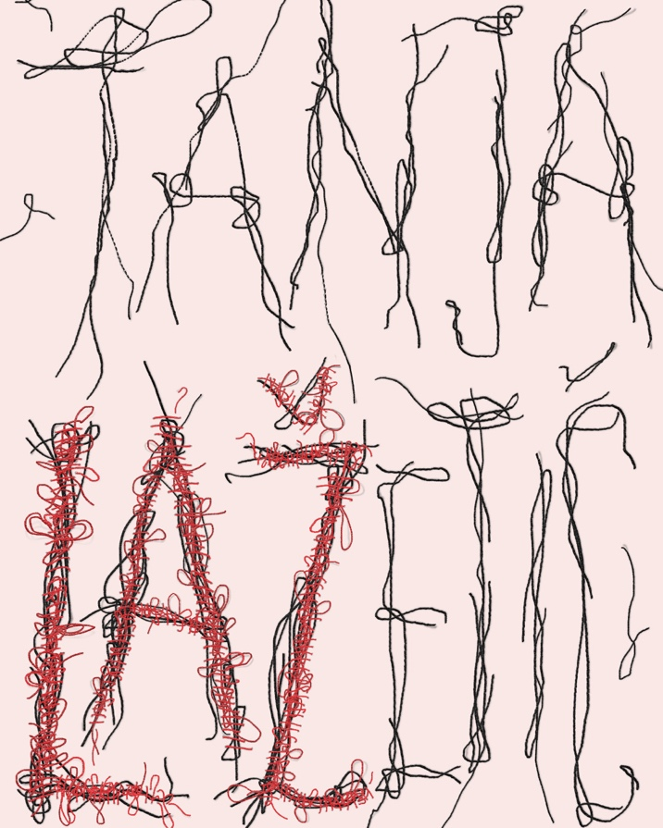
Thursday, 21 May 2026, 19.00
Exhibition opening
The opening will take place in the festive atmosphere of LJUBLJANA ART WEEKEND 2026.
Sunday, 24 May 2026, 16.00 (in English)
LJUBAW Guided tour with the artist and the curator: Tanja Lažetić and Barbara Sterle Vurnik
SUMMER MUSEUM NIGHT
Saturday, 20 June 2026, 17.00–19.00
Paper Gallery – creative workshop for children and families
Saturday, 20 June 2026, 19.00
Guided tour of the exhibition: Svit Skobir Lampič
Thursday, 9 July 2026, 17.00
Artist talk: Tanja Lažetić and Barbara Sterle Vurnik
Thursday, 30 July 2026, 17.00
Curatorial guided tour: Barbara Sterle Vurnik
Thursday, 13 August 2026, 17.00
Guided tour with the artist: Tanja Lažetić
Thursday, 27 August 2026, 17.00
Final guided tour with the artist and curator: Tanja Lažetić and Barbara Sterle Vurnik
*All events apart LJUBAW, 24. 5. / 16.00 will be held in Slovenian. For organized (private) guided tours in English please contact us at prijava@mgml.si.

Tanja Lažetić is an established Slovenian intermedia artist working in photography, video, installation, performance, ceramics, artist’s books and painting, whose practice consistently explores the questions of time, memory and identity.
The exhibition Laž (Lie) presents several decades of work by Tanja Lažetić, an established Slovenian intermedia artist active in photography, video, installation, performance, ceramics, artist’s books and painting, whose practice consistently explores the questions of time, memory and identity. This retrospective of her work centres on one of the key areas of the artist’s practice: an ongoing investigation into the relativity and fragility of the relationships between truth and falsehood, the visible and the concealed, and on questions of how we experience the past, how memories change, disintegrate, and, at the same time, are preserved. Through the lens of a female artist, without recourse to overt activism and through a subtle yet decisive visual language, she explores how personal and social contexts shape our view of reality.
In the artist’s oeuvre, the medium itself acts as an integral component of the concept, rather than merely a tool. The key creative process used by Lažetić over the years is based on cutting, stitching, cracking and layering, as well as fragmentation and reassembly. Through these acts, photographs, objects and stories are dismantled and, through appropriation and reinterpretation, reconfigured into new wholes. The basic unit of narration thus becomes not only the fragment, but also the empty, missing space, in which absence becomes the bearer of those other, invisible messages and images.
Bringing together works from 1997 to the present, including Govedji gulaš (1997), Wherever I am not (2000), Whore (2010), Lilith at the Red Sea (2018), Flowers (2019–2025), Dialogue in the Kitchen, Part II (2026), in which the artist incorporates artificial intelligence as an interlocutor, the exhibition also presents her ongoing body of artist’s books, collected as an object in The Red Box (2006–2025), conceived as a form of self-historicisation of her own archive. Throughout the installation as a whole, we can trace the central themes addressed by the artist through the iconography of the female body and identity as a site of social projection and control, where, through concealment, cutting and sewing, she opens up a space of autonomy and dismantles prejudices. She further amplifies this through the seemingly banal motif of flowers, which she employs primarily as a means of deconstructing ideals of femininity and society’s obsession with perfection. More recently, this inquiry has extended into painting, which she approaches as a conceptual and emancipatory gesture of liberating the medium from prescribed artistic norms.
Through the exhibition, the art of Tanja Lažetić establishes a field of reflection on the impermanence of truth and the ways in which it is constructed, often emerging precisely within the charged chasm between the image and its absence, particularly as the viewer becomes an active participant in the production of meaning.
–Barbara Sterle Vurnik, exhibition curator

Tanja Lažetić graduated in 1994 from the Faculty of Architecture at the University of Ljubljana. Between 1997 and 2025, she exhibited at leading (international) art venues including MG+MSUM, Ljubljana; Neuer Berliner Kunstverein, Berlin; the Real Academia de Bellas Artes de San Fernando, Madrid; the International Biennial of Graphic Arts, MGLC, Ljubljana; Brighton Photo Biennial, Brighton, England; Nanjing Festival, Nanjing, China; and Gagosian Gallery with presentations in New York, Beverly Hills and Paris, among others. Her works are held in important public collections, including the National Museum of Slovenia, Ljubljana; Museum of Modern Art, Ljubljana; the International Centre of Graphic Arts, Ljubljana; and Muzej Lah, Bled. Her photobooks are part of prominent international collections, including MOMA Artists’ Books Collection (New York), Tate Collection of Artists’ Books (London) and Bibliothèque Kandinsky (Centre Pompidou, Paris). She received an award at the UNICUM International Ceramics Triennial, Ljubljana, in 2015, and the national Rihard Jakopič Recognition award (ZDSLU, Ljubljana) in 2017.

CATALOGUE EXCERPT:
Barbara Sterle Vurnik: Women and Lies

From the outset, a telltale element of Tanja Lažetić’s practice has been a distinctly self-reflexive exploration of both personal and broader human perceptions of time, together with the associated notions of memory, transience and change. Her treatment of this truly complex concept encompasses a very broad and multifaceted framework, ranging from given social realities, the contexts of various mythologies, social constructs, and historical and artistic systems, right through to her own personal world, all of which she examines from the perspective of her female identity. In doing so, she moves beyond the stereotypical engagement with so-called women’s issues, geared around making a commentary on a narrow set of questions concerning expected or imposed social norms and prejudices, nor does she resort to any explicitly feminist or activist articulation. She approaches questions of gender, that is, her own (female) position, primarily through the mode of presentation itself, through subtlety and fragility, yet also with decisiveness. With a language therefore that in itself constitutes an eloquent gesture of a distinctly female voice, characteristically vulnerable yet resilient, which, to be heard, requires not a raised voice, but above all an appropriate medium. From today’s perspective, all this connective tissue increasingly appears as the platform on which the core of her artistic practice gains a clear outline, on the basis of which we have structured an overview of the most significant segments of the artist’s work and conceived the project as a whole.

The mentioned axis of the exhibition is, of course, just one possible perspective on the artist’s creative process, while at the same time capturing the complexity of her entire, highly diverse artistic practice. The exhibition is framed by its title Laž (Lie), which comes as the artist’s symbolic act. Derived from a play on her own name, it comes to symbolise the central concept of her art practice. In her work, the artist examines a significant segment of her core themes – the concept of truth, its relativity, internal contradictions, susceptibility to various forms of manipulation and other factors of conscious and unconscious psychological processes that come to the fore, particularly in our memory scapes. She is interested in those parts that form gaps in our memory and consciousness, those inexplicable empty spaces, omitted fragments that disrupt the clear whole, yet at the same time act as meaningful carriers of hidden messages, present precisely in their invisibility or absence. She articulates this through a characteristic method of reversal, whereby she first fragments an image, concept, thought or situation and then reassembles it into something new, though not necessarily using all the previous parts or the original whole. From this emerges a visual language constructed around a distinctive structure of numerous in-between spaces, in the form of cuts, incisions, lines and squares, as well as fragments, shards and pieces, and then through seams, adhesive tape and other points of connection between them. In this sense, Tanja Lažetić works in a highly intermedia manner, across numerous fields, from photography, ceramics, installations, performance and video to artist’s books. In her most recent works, she has also made a conceptual shift towards the medium of painting, having recognised in its processual nature a new, alternative environment for applying her thinking within the framework of the aforementioned themes.

The overview exhibition at hand extends beyond the usual format of such projects, as it unfolds through the specific nature of the works themselves, which were originally created through the artist’s reflection on her own practice. The set-up, which presents a cross-section of her decades-long creative output, is conceived in a distinct intermedia manner and spans a long period of her work, from 1997 and one of her first exhibited artworks, through some of her best-known projects, to her most recent production […].

INSTABLE: TIME, SPACE, IDENTITY
The first thing one must pause to consider when examining Tanja Lažetić’s work is undoubtedly the distinctly fragmentary narrative of her artworks, through which she explores the key themes of her exploration. As already mentioned, her narrative does not unfold in a conventional manner, through concrete or familiar information, but quite the opposite: through precisely those parts that are absent, that have gone amiss and that human perception can only apprehend as fragments of a whole. Formally, this usually involves zones of various ‘empty’, abstract forms and the ways in which these are selected and presented by the artist. In terms of meaning, however, she approaches this by dismantling, assembling and reinterpreting various pieces of information, stories and meanings drawn from existing personal and collective history. In doing so, she is particularly interested in the method of appropriation, the overt application of another artist’s work or idea into a new work as a means of articulating new meaning – a method that has always existed in art and which, as Norbert Lynton has pointed out, becomes a legitimate creative procedure only through an appropriate mode of borrowing. What interests her in this respect is the communication and the message that emerge somewhere at the margins of this process, within the new whole, while she is often also interested in what has been lost (during the transfer of data, images, meanings). Within this framework, three of her projects are of particular significance and therefore serve to introduce the exhibition, where they have been placed in dialogue with one another. [...] (Barbara Sterle Vurnik).
Artist's website:
https://www.lazetic.si/
IG @tanjalazetic
Please quote the images accordingly. For any questions contact Nataša Ilec at Natasa.Ilec@mgml.si.

In several works, for example, she clearly refers to the American artist Edward Ruscha: in Coloured People in Black and White (Yellow) (2010) to Ruscha’s Colored People (1972) – also echoing earlier references to Adrian Piper (Colored People, 1978) and Jonathan Monk (Coloured People in Black and White, 2008); in Nine Swimming Pools Behind Broken Glass (2010) to his artist’s book Nine Swimming Pools and a Broken Glass; in Twentysix Gasoline Stations Only (2010) to Twentysix Gasoline Stations (1962); and in And Not a Drop of Milk (2012) to Various Small Fires and Milk. In Whore (2010), she refers to the work Tragedy of a Venus (1975) by the Croatian conceptual artist Sanja Iveković. The source for the title A book is a book is a book is a book (2015) was found in the line “Rose is a rose is a rose is a rose” from the poem Sacred Emily by the American poet and writer Gertrude Stein. In Nude Descending a Staircase (2012), there is no question of appropriation, the artist merely refers to Nude Descending a Staircase, No. 2 (1912) by Marcel Duchamp, a pioneer of the appropriation technique, which was subsequently adopted by numerous other artists.
Norbert Lynton, The Story of Modern Art, Oxford: Phaidon Press, 1980, 52.

