BORUT KRAJNC:  Turning Point  Overview exhibition  City Art Gallery Ljubljana  17. september 2026–15. november 2026  Curator:  Sarival Sosič, PhD  mgml.si/en/city-art-gallery/exhibitions/740/borut-krajnc/ | 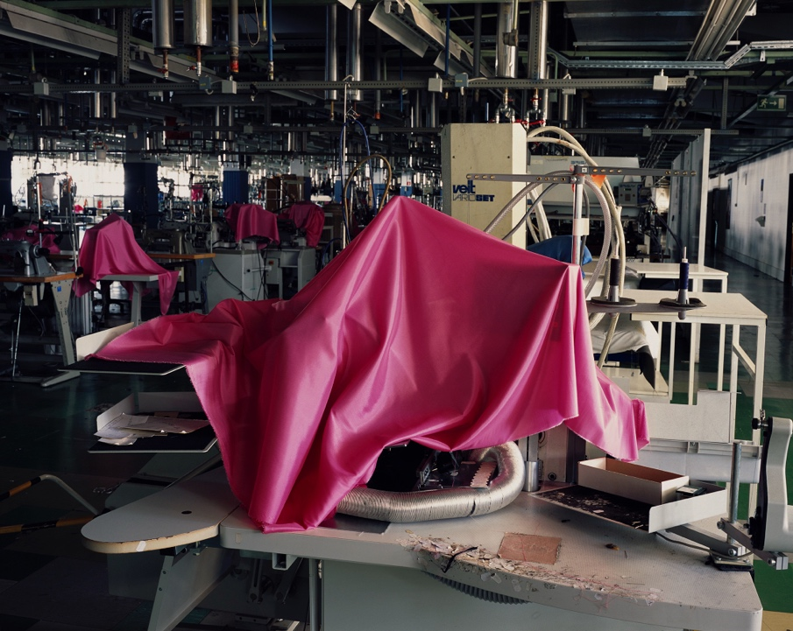
Thursday, 17 September 2026, 19.00
Exhibition opening

Thursday, 24 September 2026, 17.00
Conversation on the exhibition: Emptiness and Turning Point in Photography and Contemporary Society
hosted by Sarival Sosič, PhD; guests: Sandra Bašić Hrvatin, PhD; Petja Grafenauer, PhD; Marcel Štefančič Jr., MA; and Borut Krajnc

Thursday, 1 October 2026, 17.00
Guided tour with the artist: Borut Krajnc and Sarival Sosič, PhD

Thursday, 8 October 2026, 17.00
Curatorial guided tour: Sarival Sosič, PhD

Thursday, 22 October 2026, 17.00
Guided tour: Miha Colner and Sarival Sosič, PhD

Thursday, 12 November 2026, 17.00
Final guided tour with the artist and curator: Borut Krajnc and Sarival Sosič, PhD

How are we to perceive the present, woven from a multitude of individual and often contradictory moments, lies at the heart of Borut Krajnc’s photographs and photographic series. With thematically and conceptually cohesive cycles and a carefully considered selection of works, he presents a retrospective exhibition of his socially engaged photographic oeuvre at the Ljubljana City Art Gallery. The exhibition Transformation brings together the photographic cycles Emptiness (2005–2008), Path (2015), Politics (2012–2015), Pressure (2020), Transitions (2020–2021), and the cycle Turning Point, which includes the series Mura (2009–2014), Adria Airways (2019), and Maribor Foundry – MLM (2024–2025). The titles of these individual series alone already suggest that emptiness and transformation are at the heart of Krajnc’s photographic practice. Over the past two decades, these interconnected themes have shaped his reflections, sensibility, and critical understanding of social reality.

Borut Krajnc's exhibition offers an insightful photographic look into key social and political turning points of the Slovenian transition, through which the author, as a chronicler of his time, visually exposes the impact of capitalism, political populism, and media and consumer saturation on contemporary everyday life.
Borut Krajnc (b. 1964) is a documentary photographer and photojournalist as well as an independent artist working in the field of contemporary photography. While studying economics, he began his career as a photographer for the student newspaper Tribuna, later working for the daily newspaper Demokracija. Since 1991, he has been a staff photographer for the weekly magazine Mladina. Since 2000, in addition to documentary and photojournalistic photography, he has created conceptually driven series, including Proposal (2004), Emptiness (2005–2008), Politics (2012–2015), Path (2015–2018), Pressure (2020), and Transition (2020–2021). In his creative practice, he typically explores the intersections of society, politics, and the economy, employing both classical documentary and distinctly conceptual approaches. He lives and works in Ljubljana.

Borut Krajnc's overview exhibition offers a comprehensive insight into the oeuvre of one of the most prominent Slovenian photographers and photojournalists, who, throughout his work spanning several decades, has consistently documented the social, economic, and political shifts of modern history. The exhibition layout is based on an analysis of the transformation of Slovenian society and the broader region of the former Yugoslavia and Eastern Europe, which after 1989 was marked by the transition from a socialist system to parliamentary democracy and a market economy.
Borut Krajnc began his career in the late 1980s at the student newspaper Tribuna, continued at the newspaper Demokracija, and in 1991 became a member of the photographic editorial team of the weekly Mladina, where he still works today. His original expression was distinctly journalistic, adapted to the format of print media and photo-reportage, through which he documented, among other things, the independence war in Slovenia, landmark events in Russia in 1993, and protests against global capitalism.
Due to changing conditions in the contemporary media landscape, smaller budgets for in-depth reporting, and the pressure for instant reporting, Krajnc's artistic practice began a deliberate shift toward a museum-gallery format. This turn allowed him to conduct longer-term research into selected phenomena and to transition from daily informational photography to conceptual, multifaceted visual series that maintain a sharp social engagement.
Through chronologically and thematically linked series, the exhibition exposes the mechanisms of the neoliberal turn, the commodification of everyday life, and the crisis of public institutions. In the cycle The Proposal (Snubitev), the author records pro-European enthusiasm and dogmatic discourse during Slovenia's accession to the European Union and NATO, while in the series Emptinesses (Praznine), through empty billboard spaces, he visualizes an anomaly in the system that foreshadowed the collapse of financial capitalism in 2008. The cycle Politics (Politika) analyzes the rise of political populism and simplified rhetoric in election campaigns, and the series The Path (Pot), through large-format photographs of refugees, addresses the question of humanism and European historical amnesia. The author highlights a critique of capital's influence on media independence with enlarged, purchased cover pages in the series Pressure (Pritisk), while the cycle Crossing (Prehajanje) visualizes states of emergency and the restriction of personal freedoms through images of empty streets during the pandemic.
Krajnc's images of fragments of reality function as an attempt to objectively document the existing state of affairs without direct or moralizing commentary. The author merely shows selected phenomena, processes of privatization, and the stratification of the population, presenting them to the public with a sufficient degree of distance that demands active mental reflection and interpretation from the visitor. His oeuvre thus does not merely record local specifics of the Slovenian transition, but establishes a universal chronicle of the mature era of global capitalism and the changes reshaping the foundations of modern civilization.

Excerpts from the Exhibition Catalogue
Dr. Sarival Sosič: Emptiness and the Turning Point
[...] The exhibition and the comprehensive catalogue consist of selected photographic series accompanied by texts by various authors. Through analysis and interpretation, these texts focus on individual cycles, themes, and conceptual emphases within Krajnc’s oeuvre. It is therefore appropriate, in this introductory text, to highlight, above all, certain common characteristics of his photographic approach.
The first among these is documentary precision, evident in his depictions of public spaces, political events, industrial environments, media scenes, and diverse social gestures. Krajnc photographs thoughtfully and attentively. His frame is never an arbitrary fragment of reality, but the result of a careful observation of the relationships between people, objects, architecture, inscriptions, symbols, and empty spaces. A second characteristic is critical distance. Krajnc’s photographs do not merely record what happened; rather, they direct the viewer toward questions about why a particular scene was possible in the first place, which social mechanisms created it, and what it reveals about the community in which it arose. His critical perspective is never based on overt moral judgement, but rather on a precise selection of the moment, the subject, and the interrelationships within the image itself. Equally significant is his persistent interest in various forms of emptiness and reversal. Images of vacant billboards, newspaper covers, storefronts, streets, industrial spaces, and political events do not appear as neutral motifs in his work. The emptiness within them becomes itself a document of the social condition. It reveals the absence of content, the exhaustion of a particular system, the loss of a shared space, or the traces of political and economic decisions. In the series Emptiness, blank advertising billboards are not merely geometric surfaces within the landscape. They are remnants of a system of consumerist persuasion that has temporarily lost its message, yet whose infrastructure remains present. Their whiteness does not signify neutrality. It reveals the space, architecture, sky, and environment that advertisements usually obscure. This emptying thus brings about a turning point in perspective itself. Similarly, industrial ruins and scenes associated with corporate bankruptcies are not merely documents of economic collapse either. They become images of lost labour, community, knowledge, and social security. Empty production halls retain traces of former activities, but precisely because of the absence of people, they bear even more striking witness to the consequences of political and economic decisions. The photographs from the Bankruptcies series therefore speak simultaneously of the past and the present. They document specific instances of corporate collapse while also revealing a broader societal turning point in which the value of collective labour has given way to the logic of capital, privatisation, restructuring, and accountability without a clearly defined bearer.
Another defining characteristic of Krajnc’s work is the conceptual integration of individual motifs within a broader visual and thematic framework. His photographic series emerge from an interweaving of photojournalism, documentary analysis, and critical thought. Individual photographs function as parts of a broader narrative, and their sequencing generates a meaning that transcends the documentary nature of the individual image. In this respect, many of his motifs resemble literary narratives or visual essays. Not because they stray from reality, but because they transform concrete phenomena into reflections on social systems. Krajnc photographs moments when the system falters, when its outward appearance is stripped away, and when its shortcomings, contradictions, flaws, deceptions, and injustices become visible. In these moments, photography transcends the role of a neutral record. It becomes a space of revelation. What might be overlooked in the everyday flow of events comes into sharp focus within the photographic frame. The void reveals the structure, while the turning point exposes the relationships that had until then remained concealed beneath the apparent stability of the social order. [...]
— Dr. Sarival Sosič, PhD, exhibition curator

Miha Colner: Chronicler of the Great Turn
[...] Through his artistic practice, Borut Krajnc continually holds up a mirror to the world, calling into question certain taken-for-granted ideas and social processes of recent history. Amid the whirlwind of changes that have swept through the past thirty-five years, bringing about the liberalisation of the political and economic systems, fundamental questions regarding basic human freedoms and rights—such as equality before the law and social justice—remain unresolved. The transition to democracy—both in Slovenia and in the broader region of the former Eastern Bloc—took many forms, yet they all led, to a greater or lesser extent, towards radical individualism, consumerism, and the deregulation of social systems. Krajnc has consistently and continuously documented the establishment of a new political paradigm founded on the ideology of success and individualism, and on a shift toward extreme materialism. He has chronicled a new world for a new kind of person.
Krajnc’s depictions of fragments of reality represent an attempt at objectively documenting existing conditions, as he never offers direct commentary but instead remains within an ambiguous and complex visual narrative. Maintaining a sufficient degree of distance, he merely presents, reveals, and places the selected phenomena and situations before the audience, which must then engage intellectually in order to decipher, connect, and interpret his works to the extent that they can be situated within their own context and value system. After all, Krajnc is well aware that he is documenting ongoing social changes in real time, here and now, and that—as historians say—it will take at least thirty years to historically assess the current state of affairs.
The photographs of the Slovenian version of the transition to democracy are, in a way, very particular, grounded in local specifics and contexts, yet at the same time universal enough to establish a connection with situations in other countries of the former Eastern Bloc. Across the whole region of Central and Eastern Europe, these same processes of privatisation, the deterioration of once-taken-for-granted public services, and the polarisation of the population continue to unfold today. The historical moment of the introduction of libertarian ideology and social Darwinism coincided with the gradual processes of deindustrialisation and demographic decline in Europe, which corresponds to the concept of the decline of Western civilisation as articulated by the thinker Emmanuel Todd in his book The Defeat of the West (2024). The decline of civilisations is an inevitable historical fact—a process that typically unfolds gradually and slowly, yet inevitably. In the context of the broader West, this decline is unfolding through a process of neoliberal turn which is gradually changing society and, in doing so, in all likelihood, destroying its very foundations. Krajnc is a chronicler of this great turn, which is still unfolding.
— Miha Colner

Please cite image material correctly.
For additional questions, contact Nataša Ilec at Natasa.Ilec@mgml.si.

The exhibition will be accompanied by an extensive catalogue, which, in addition to the exhibition layout and an overview of individual selected works, will feature expert texts by Marcel Štefančič Jr., M.A., Dr. Petja Grafenauer, PhD, Dr. Andrej Medved, PhD, Dr. Sandra Bašić Hrvatin, PhD, Dr. Mladen Dolar, PhD, Miha Colner, and the exhibition curator, Dr. Sarival Sosič, PhD.

The philosopher H. Bergson understands emptiness as a dynamic concept. Emptiness is not an absolute nothingness, but rather a tension between memory and the future turning point, however, is not merely a change in external circumstances, but a turning point of perspective itself: the world is not a collection of static forms, but a living duration in which every absence already contains the potential for a new beginning.

